Учебная дисциплина: Английский язык 1 курс
Электронный адрес: nona41771@mail.ru
Дата сдачи задания: 19.05.2020

Прочитайте и переведите текст на русский язык. Выполните задание по тексту.

French cuisine
French cuisine is characterized by its extreme diversity. In that, it can only be compared to Chinese cuisine or the cuisine of India.
Traditionally, each region of France have their own distinctive cuisine: cuisine from northwest France uses butter, cream, and apples; Provençal cuisine (from the southeast) favors olive oil, herbs, and tomatoes; cuisine from southwest France uses duck fat, foiegras, porcini mushrooms (cèpes), and gizzards; cuisine from northeastern France is reminiscent of German cuisine and uses lard, sausages, beer and sauerkraut.
What is known outside of France as "French cuisine" is the elaborated cuisine of the higher classes of Paris, served in restaurants for hefty prices. Average French people do not eat or prepare this cuisine in their everyday life, and rather eat the regional cuisine of the region where they are located.
Wine and cheese are an integral part of French cuisine (both Paris high cuisine and regional cuisines), both as ingredients and accompaniments. France is known for its large range of wines and cheeses.
For French people, cooking is part of culture, and cooking and good food are well appreciated. The French generally take a high pride in the cuisine of their country, and some, particularly in the older generations, are reluctant to experiment with foreign dishes.

Food
The normal meal schedule is to take a light breakfast in the morning (consisting of bread and/or cereal, possibly coffee and some fruit, perhaps croissants), a lunch at some point between noon and 2PM, and dinner in the evening. A normal complete meal consists in appetizers (perhaps raw vegetables or salad), a main dish (generally, meat or fish with a side of vegetables, pasta, rice or fries), some cheese and/or dessert (fruit or cake). With contemporary lifestyle, especially the reduced number of housewives, the French rely a lot more on canned or frozen foods for weekdays. Cooking evening or weekend meals from fresh ingredients is still popular. In most cities, there are street markets selling vegetables, meat and fish, several times a week; however, most of those products are now bought at hyper- or supermarkets.

Drink
Traditionally, France has been a culture of wine consumption. While this characteristic has lessened with time, even today, 98.67% of the French consume wine every day. The consumption of low-quality wines during meals has been greatly reduced. Beer is especially popular with the youth.
Schematically, French restaurant cuisine can be divided into:

Cuisine bourgeoise
Cuisine bourgeoise, which includes all the classic French dishes which are not (or no longer) specifically regional, and which have been adapted over the years to suit the taste of the affluent classes. This type of cooking includes the rich, cream-based sauces and somewhat complex cooking techniques that many people associate with French cuisine. At the 'top end' of this category is what is known as haute cuisine, a highly complex and refined approach to food preparation and kitchen management.
Because this kind of cuisine is what is often served abroad under the name of "French cuisine", many foreigners mistakenly believe that typical French meals involved complex cooking and rich, un-dietetic dishes. In fact, such cooking is generally reserved for special occasions, while typical meals are simpler.

Cuisine du terroir
Cuisine du terroir, which covers regional specialities with a strong focus on quality local produce and peasant tradition. Many dishes that fall in this category do not stand out as stereotypically "French," sometimes because regional cooking styles can be quite different from the elaborate dishes seen in French restaurants around the world.
Nouvelle
Cuisine nouvelle or nouvelle cuisine, which developed in the 1970sas a reaction to traditional cuisine, under the influence of chefs such as Michel Guérard. This type of cooking is characterized by shorter cooking times, much lighter sauces and dressings, and smaller portions presented in a refined, decorative manner. Its modern, inventive approach sometimes includes techniques and combinations from abroad (especially Asia) and has had a profound influence on cooking styles all over the world.
Ответьте на вопросы по тексту :
1. What does a normal complete meal consist of?
2. What is integral part of French cuisine?
3. What can French restaurant cuisine be divided into?

4. What sauces does cuisine bourgeoise include?

5. What is nouvelle cuisine characterized by?
6. What cuisine can French cuisine be compared to?
7. What cuisine uses duck fat, foiegras, porcini mushrooms (cèpes) and gizzards?

Учебная дисциплина: Английский язык 1 курс
Электронный адрес: nona41771@mail.ru
Дата сдачи задания: 21.05.2020
Past Continuous Tense - прошедшее продолженное время - в английском языке свидетельствует о том, что действие происходило, длилось в течении какого-то периода времени в прошлом.
Нужно запомнить два момента использования этого времени:

- Если в предложении указано точное время протекания действия, например, at 5 o’clock yesterday (в 5 часов вчера) , from 5 till 7 p.m. (с 5 до 7 часов вечера), at this time yesterday (вчера в это же время), the whole morning (все утро, весь вечер) и т.п.
• I was having breakfast at 10 yesterday – вчера в 10 я завтракал
• He was watching TV the whole evening yesterday – он смотрел телевизор весь вечер вчера.
- 2. Если момент времени выражен глаголом прошедшего времени. Например, «когда я вернулся домой, моя жена спала». Здесь оба действия происходили в прошлом, но одно из них совершилось одномоментно (вернулся), а второе — длилось (спала). Поэтому глагол, выражающий одномоментное действие (вернулся), будет стоять в Past Indefinite tense, а продолжительное действие (спала) будет переведено, соответственно, в Past Continuous tense: When I returned home, my wife was sleeping.

Если буква -e на конце не произносится, то она опускается перед окончанием -ing, если произносится — просто добавляется -ing..
to write → writing (писать) to free → freeing (освобождать)
Окончание -ie меняется на -y to lie → lying (лгать)
Окончание -y всегда остается на месте to play → playing to try → trying
Согласная на конце удваивается, если перед ней стоит ударная гласная. Согласная не удваивается, если ударная гласная стоит в другом месте или согласной предшествует долгий гласный звук
to get → getting (получать) to remember → remembering (помнить) to cool → cooling (охлаждать)
Конечные буквы w и x перед -ing не удваиваются
to mix → mixing (смешивать) to show → showing (показывать)

Маркеры времени Past Continuous
Узнать время Past Continuous можно по особым словам-маркерам, встречающимся в предложении. Обычно они отвечают на вопрос «Когда это происходило?».
- at the moment (в тот момент)
- when (когда)
- while (в то время, как)
- as (так как)
- all night (long) (всю ночь)
- all morning (все утро)
- all day (long) (весь день)
- last Sunday (в прошлое воскресенье)
- last month (в прошлом месяце)
- last year (в прошлом году)
- from Monday to Wednesday (с понедельника по среду)
- at 3:15 pm
- at 6 yesterday
из-за своей собаки
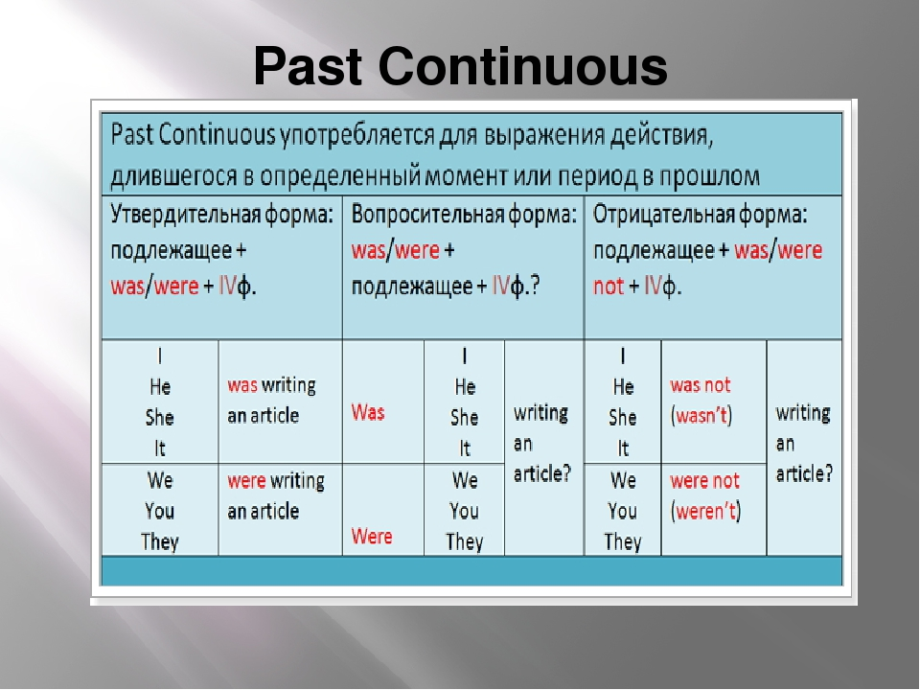

IV форма глагола - это к основной форме глагола + ing
To cook = cooking

Задание 1. Напишите глаголы в форме Past Continuous с местоимением, данным в скобках. Уделите особое внимание правописанию.
Пример: play (I) - I was playing
- sit (we)
- run (he)
- lie (they)
- live (she)
- ski (I)
Задание 2 Past Continuous Сделайте предложения отрицательными.
- The teacher was explaining the exercise to the pupils 2. Amanda was travelling around Africa at that time. 3. We were having a Music lesson at ten o’clock yesterday. 4. I was doing the shopping yesterday. 5. Martin was visiting his aunt at this time yesterday. 6. The girls were preparing for the concert. 7. They were flying to Wales at 6 o’clock yesterday. 8. It was raining hard all day last Tuesday. 9. Mike and Jess were walking in the park last evening. 10. He was choosing the books in the library then.
Задание 3. Past Continuous Сделайте предложения вопросительными.
1. We were having lunch in the canteen. 2. She was singing a lovely song. 3. You were speaking to your boss. 4. George was sitting in the armchair by the fireplace. 5. Jane and Margaret were going to the airport. 6. The baby was crying. 7. It was getting dark. 8. We were waiting for my cousin. 9. The woman was watching the children on the playground. 10. The tourists were taking photos in front of the palace.

