Учебная дисциплина: Английский язык 1 курс
Электронный адрес: nona41771@mail.ru
Дата сдачи задания: 18.05.2020

1.Перевести текст.

Nationality Stereotypes
The world is so different! There are so many nationalities; each has its own history, customs and traditions. Certainly people from diverse countries have dissimilar behavior, breeding, trait and characteristics. That is why we understand a word “stereotype” as the fixed conception that is generally characterize a person of some nationality. In my opinion we should not judge about a people or a group of people by stereotypes but nevertheless a certain stereotype does exist. There are many ways of investigating stereotypes. One of the most obvious is to ask people what trades characterizethe British, the Russians, the Americans and other nations. Results are expected. English are said to be prim without any emotions. Weather is the most important topic in the land and you must be good at discussing the weather. Any weather is good for them. The British people have certain characteristics which are supposedly typical for them. But many things are regarded as typically British are no longer representative of modern life. It is also belief that Britain is a land of traditions. It is not always true in everyday lives the British as individuals, and some of them are probably less follow traditions. According to the stereotypes English are also thought to be reserved, conservative, shy, suspicious accepting new ideas, responsible, honest and unemotional. But I think these stereotypes are far from true, especially in today`s world. Nationality stereotypes are often described in anecdotes, humorous stories and private diaries. For example films about Wild West Americans who aredynamic and fearless. They show us men strength in fights, gun fighting and horse riding skills. But in life they are often pragmatist and materialist. They like freedom very much. Self-reliance usually is the second moral value for Americans. The third American value is competition. In spite of the fact that society can`t consist only of winners the Americans believe that every problem has a solution. The fifth national value is material wealth. Most Americans believe wealth is a reward for hard work. The sense of humor is the special aspect of a culture. Many people say they do not have this sense, and if they try to make a joke it is often silly. As for the Russian, they are considered to be tough and brave. These stereotypes are derived from books, films and other cultural media. As any nation the Russians have both positive and negative sides. On the one hand, people are hard-working, frank with strong will and hospitable to foreigners. On the other hand sometimes they cheat and unwilling views and ideas with other people. Certainly, there are a lot of stereotypes about other nations. But first of all, we should remember that we are all individuals. In conclusion, I would like to say that stereotypes are a part of human life. They are certainly not reliable description of individual people but they still exist.
2. Past Continuous Tense - прошедшее продолженное время - в английском языке свидетельствует о том, что действие происходило, длилось в течении какого-то периода времени в прошлом.
Нужно запомнить два момента использования этого времени:

- Если в предложении указано точное время протекания действия, например, at 5 o’clock yesterday (в 5 часов вчера) , from 5 till 7 p.m. (с 5 до 7 часов вечера), at this time yesterday (вчера в это же время), the whole morning (все утро, весь вечер) и т.п.
• I was having breakfast at 10 yesterday – вчера в 10 я завтракал
• He was watching TV the whole evening yesterday – он смотрел телевизор весь вечер вчера.
- 2. Если момент времени выражен глаголом прошедшего времени. Например, «когда я вернулся домой, моя жена спала». Здесь оба действия происходили в прошлом, но одно из них совершилось одномоментно (вернулся), а второе — длилось (спала). Поэтому глагол, выражающий одномоментное действие (вернулся), будет стоять в Past Indefinite tense, а продолжительное действие (спала) будет переведено, соответственно, в Past Continuous tense: When I returned home, my wife was sleeping.

Если буква -e на конце не произносится, то она опускается перед окончанием -ing, если произносится — просто добавляется -ing..
to write → writing (писать) to free → freeing (освобождать)
Окончание -ie меняется на -y to lie → lying (лгать)
Окончание -y всегда остается на месте to play → playing to try → trying
Согласная на конце удваивается, если перед ней стоит ударная гласная. Согласная не удваивается, если ударная гласная стоит в другом месте или согласной предшествует долгий гласный звук
to get → getting (получать) to remember → remembering (помнить) to cool → cooling (охлаждать)
Конечные буквы w и x перед -ing не удваиваются
to mix → mixing (смешивать) to show → showing (показывать)

Маркеры времени Past Continuous
Узнать время Past Continuous можно по особым словам-маркерам, встречающимся в предложении. Обычно они отвечают на вопрос «Когда это происходило?».
- at the moment (в тот момент)
- when (когда)
- while (в то время, как)
- as (так как)
- all night (long) (всю ночь)
- all morning (все утро)
- all day (long) (весь день)
- last Sunday (в прошлое воскресенье)
- last month (в прошлом месяце)
- last year (в прошлом году)
- from Monday to Wednesday (с понедельника по среду)
- at 3:15 pm
- at 6 yesterday
из-за своей собаки
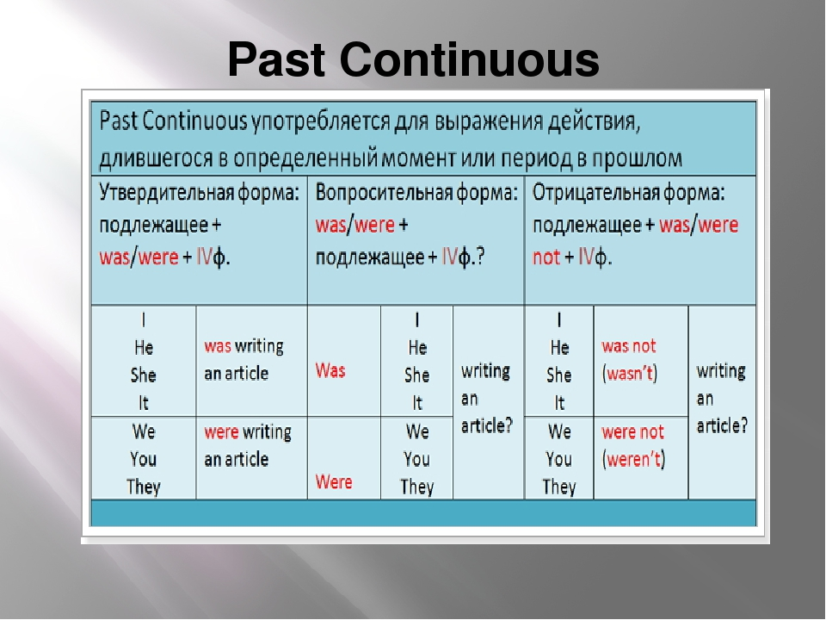

IV форма глагола - это к основной форме глагола + ing
To cook = cooking
Упражнение 1. Раскройте скобки, поставив глаголы в фоpму Past Continuous.
- While I ___________ (to copy) the exercise, my friends __________ (to describe) a picture.
- When we came in, the children __________ (to clean) their desks.
- We met her at the bus stop. She ___________ (to wait) for the bus.
- Some of the children ________ (to ski) while other children ___________ (to skate). Everybody __________ (to have) a lot of fun.
- When we came the family ________ (to get) everything ready for Christmas. Bob and Helen _________ (to decorate) the Christmas tree.
- The girls _________ (to feed) the birds in the garden while the boys _______ (to make) a bird-house.

